Lab Procedure for part A:
- Obtain the steel projectile ball, which may be in the pendulum bob.
- Clamp the base of the ballistic pendulum to the lab table. Base should be secure so that it does not recoil but is not overly tight. Put on safety glasses. Raise and secure the pendulum in the horizontal position. Load the steel projectile ball into the pendulum launcher and use the plunger to set the launcher at the medium-range position. Check to see that the ball is against the launcher spring before you fire the launcher. Lower the pendulum and set the angle measurement to zero. Fire the ball into the pendulum and record the maximum angle of the pendulum swing to the nearest ½ degree in Data Table 1. Repeat five more times.
- Calculate the average maximum angle and record in Data Table 1.
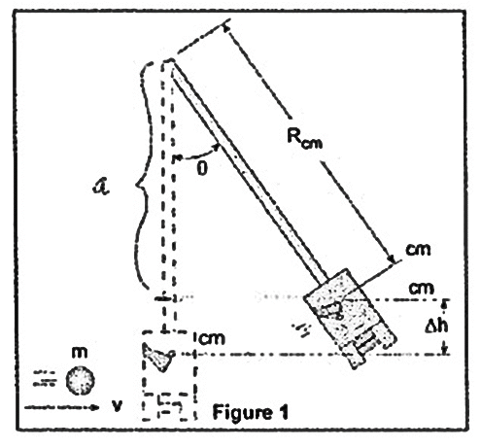
- Carefully remove the pendulum from the support by removing the mounting screw at the top. Replace the screw so it is not lost. Measure the total mass of the steel ball and the pendulum. Remove the steel ball and measure the pendulum’s mass and record in Table 1. Determine the mass of the ball and record in Data Table 1. Measure R (Pendulum length from pivot to center of mass) and record in Data Table 1.
- Calculate h (distance the center of mass of the pendulum rises) using your measured average maximum angle and R_{cm} found in the previous step. Record h in Data Table 1.
- From the data, compute the magnitude of the initial velocity.
Data Table 1: The Ballistic Pendulum
Purpose: To determine the magnitude of initial projectile velocity using a ballistic pendulum
Trials | Resultant Angle  (degrees) | System Details  (Recommended to use meters, kilograms, joules)
1 |  | $$M=__________$$  Mass of pendulum  (excluding ball) | $$m=__________$$mass of steel ball | $$R=__________$$  Pendulum length from pivot to center of mass
2
3 |  | $Calculate the maximum vertical height of the pendulum$using the formula $h=R\left(1-\cos{θ}\right)$  $$h=__________$$
4
5 |  | Show work using the formula $v_{x_{0}}=\left(\frac{m+M}{m}\right)\sqrt{2gh} and g=9.81\frac{m}{s^{2}}$  $$Computed v_{x_{0}}=__________$$
6
Average
$$θ$$
Reflection and Analysis
After completing part A of the lab, answer the following questions.
Procedure A: The Ballistic Pendulum
Is the collision between the ball and the pendulum elastic or inelastic? Why?

Calculate the kinetic energy of the system just before the collision using the initial velocity found in part A.
Hint: (Consider what was moving at the initial.)

Initial Velocity before collision (from experiment): ____________ Mass before collision: ____________
(Use the formula $KE=\frac{1}{2}mv^{2}$)

KE before collision:____________

Calculate the kinetic energy of the system just after the collision using the experimental value of h found in part A and the formula $v_{f}=\sqrt{2gh}$ to determine the initial velocity of the ball and pendulum combination.
Hint: (Consider what was moving after the collision.)

h: ___________ Mass after collision: ____________
Use the formula $v_{f}=\sqrt{2gh}$ to determine the initial velocity of the ball and pendulum.
(Show work)

Velocity (from $v_{f}formua)$: ____________
(Use the formula $KE=\frac{1}{2}mv^{2}$)

KE after collision: ____________
Using the computed values for kinetic energy before and after the collision, compute the percent of the kinetic energy lost during the collision.
$$Percent of KE_{Gained/Lost}=\frac{KE_{after}-KE_{before}}{KE_{before}}×100\%$$

$Percent of KE_{Gained/Lost}$:____________

Lab Procedure for part B:

WARNING: USE CAUTION WHEN FIRING THE PROJECTILE AND ENSURE THAT THERE IS SUFFICIENT SPACE TO SAFELY CONDUCT THE EXPERIMENT. IT IS RECOMMENDED THAT YOU WEAR EYE PROTECTION AND REMAIN AWARE OF OTHER GROUPS CONDUCTING THE EXPERIMENT.

- Obtain the steel projectile ball, which may be in the pendulum bob.
- Clamp the base of the ballistic pendulum to a lab table. Base should be secure so that it does not recoil but is not overly tight. Put on safety glasses. Raise and secure the pendulum in the horizontal position. Load the steel projectile ball into the pendulum launcher and use the plunger to set the launcher at the medium-range position. Check to see that the ball is against the launcher spring before you fire the launcher.
- Fire the ball off the edge of the table and determine where to put a sheet of blank paper and carbon paper to capture the landing spot of the subsequent trials. Tape the paper to the ground and lay a sheet of contact paper over it (do not tape the contact paper). Repeat five times. It is important that the spring cannon is fired from the same position each time.
- Record the horizontal distance traveled for each trial measuring from where ball left the cylinder of the device and began its free fall.
- Record the vertical distance traveled for each trial measuring from where ball left the cylinder of the device and began its free fall.
- From the data, compute the magnitude of the initial velocity.
- Once you have completed both parts A and B of the experiment, compute the percent difference.
Data Table 2: Determination of Initial Velocity of a Projectile from Range-Fall Measurements
Purpose: To determine the magnitude of initial projectile velocity from range-fall measurements
Trials | Range  (meters) | Vertical distance of fall $y=__________$
1 |  | Show work using the formula $v_{x_{0}}=\sqrt{\frac{gx^{2}}{2y}} and g=9.81\frac{m}{s^{2}}$  $$Computed v_{x_{0}}=__________$$
2
3
4
5 |  | Compute the percent difference between results in parts A and B. $(Show work)$  $$Percent Difference=__________$$
Average
Range
$$x$$

Reflection and Analysis
After completing parts A and B of the lab, answer the following questions.
Procedure B: Initial Velocity from Range-Fall Measurements
What effect does the force of gravity have on the horizontal velocity of the projectile?

What effect would air resistance have on the range of the projectile?
*Ensure you are including correct units in all calculations and solutions.

